CREATING A 'DICE'

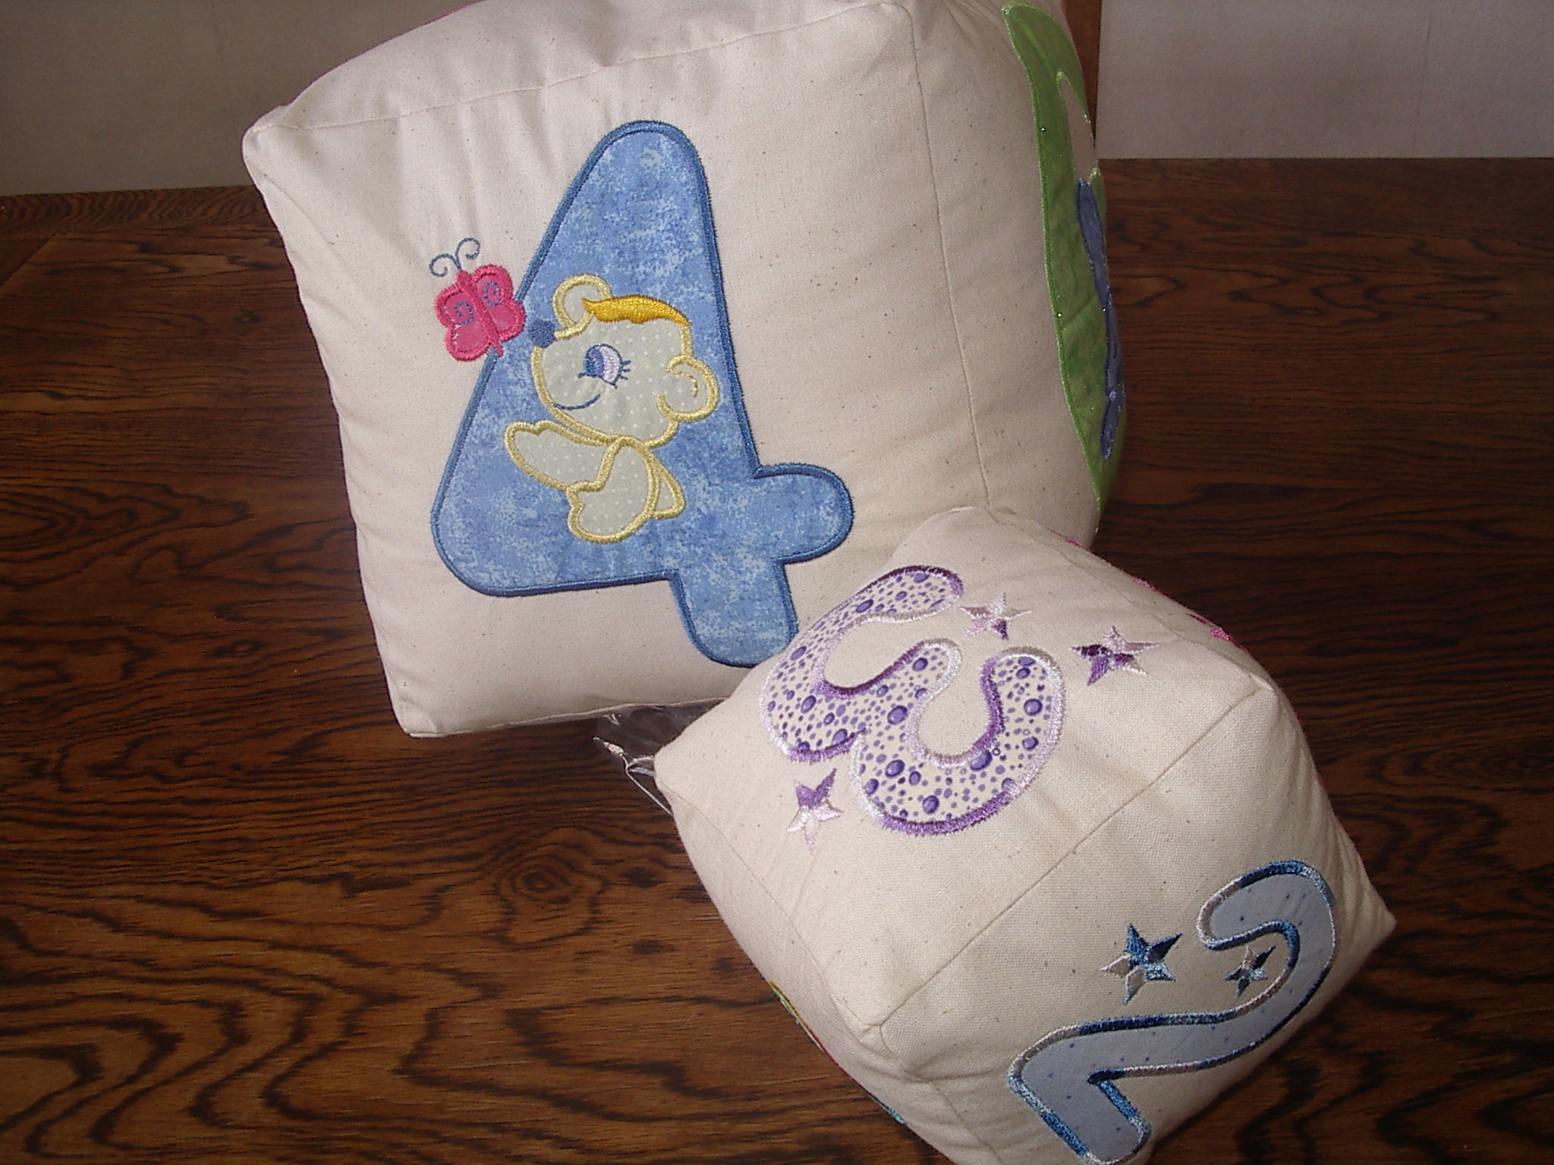
This is such a simple project to make, and I can confirm that my little ones absolutely love the dice, in addition to them being a learning tool.

MATERIALS NEEDED
6 designs of any sort – this is where you can use up all your test sew outs.
Filling – we call it Kapok in New Zealand, I am sure you will be able to get a similar product from your local sewing or craft shop.

GETTING STARTED
You can make the dice to any size, and there really are only 2 'tricks' to making them.

First of all determine the size of your blocks, then add a seam allowance – being a quilter I use ¼ inch seam allowances, so I made my small dice as follows:

I chose 5 inches as my size of blocks, so added ½ inch (¼ inch seam allowance each side of the square) and therefore cut my blocks to 5 ½ inch square.

1st Trick
When you arrange the square to sew, you need to reverse the number 6 (or whatever design you have in that position) as per the photo.

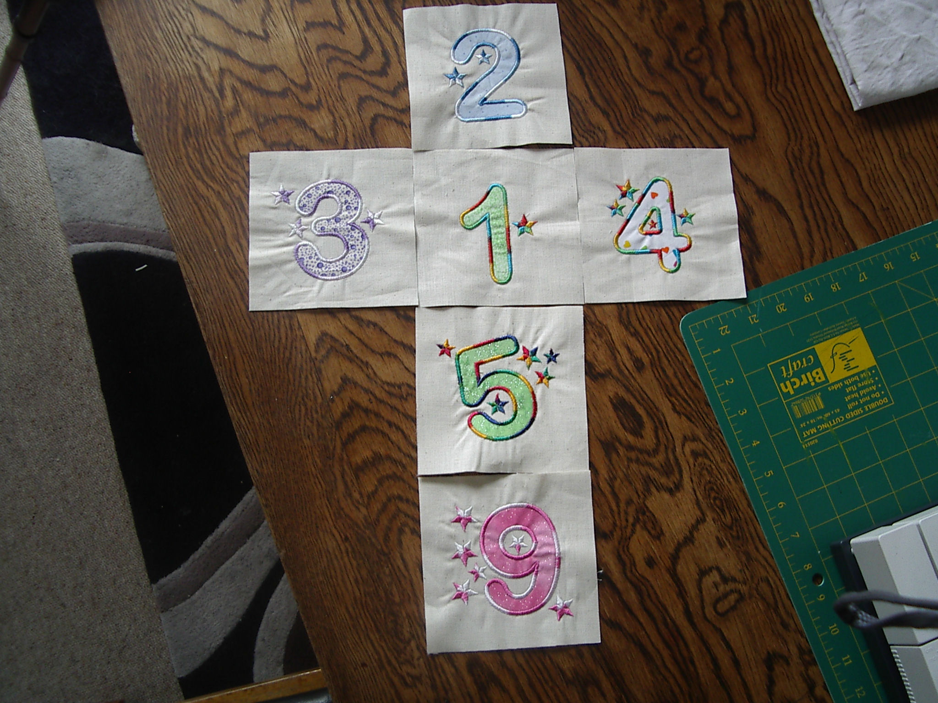
You can sew the seams in any order, just ensure you follow the picture.

2nd Trick
When you sew the blocks together – do not sew from edge to edge – instead start at your seam allowance and stop at your seam allowance – ie I used ¼ inch seam allowances, so I start ¼ inch in, and stopped ¼ inch in.

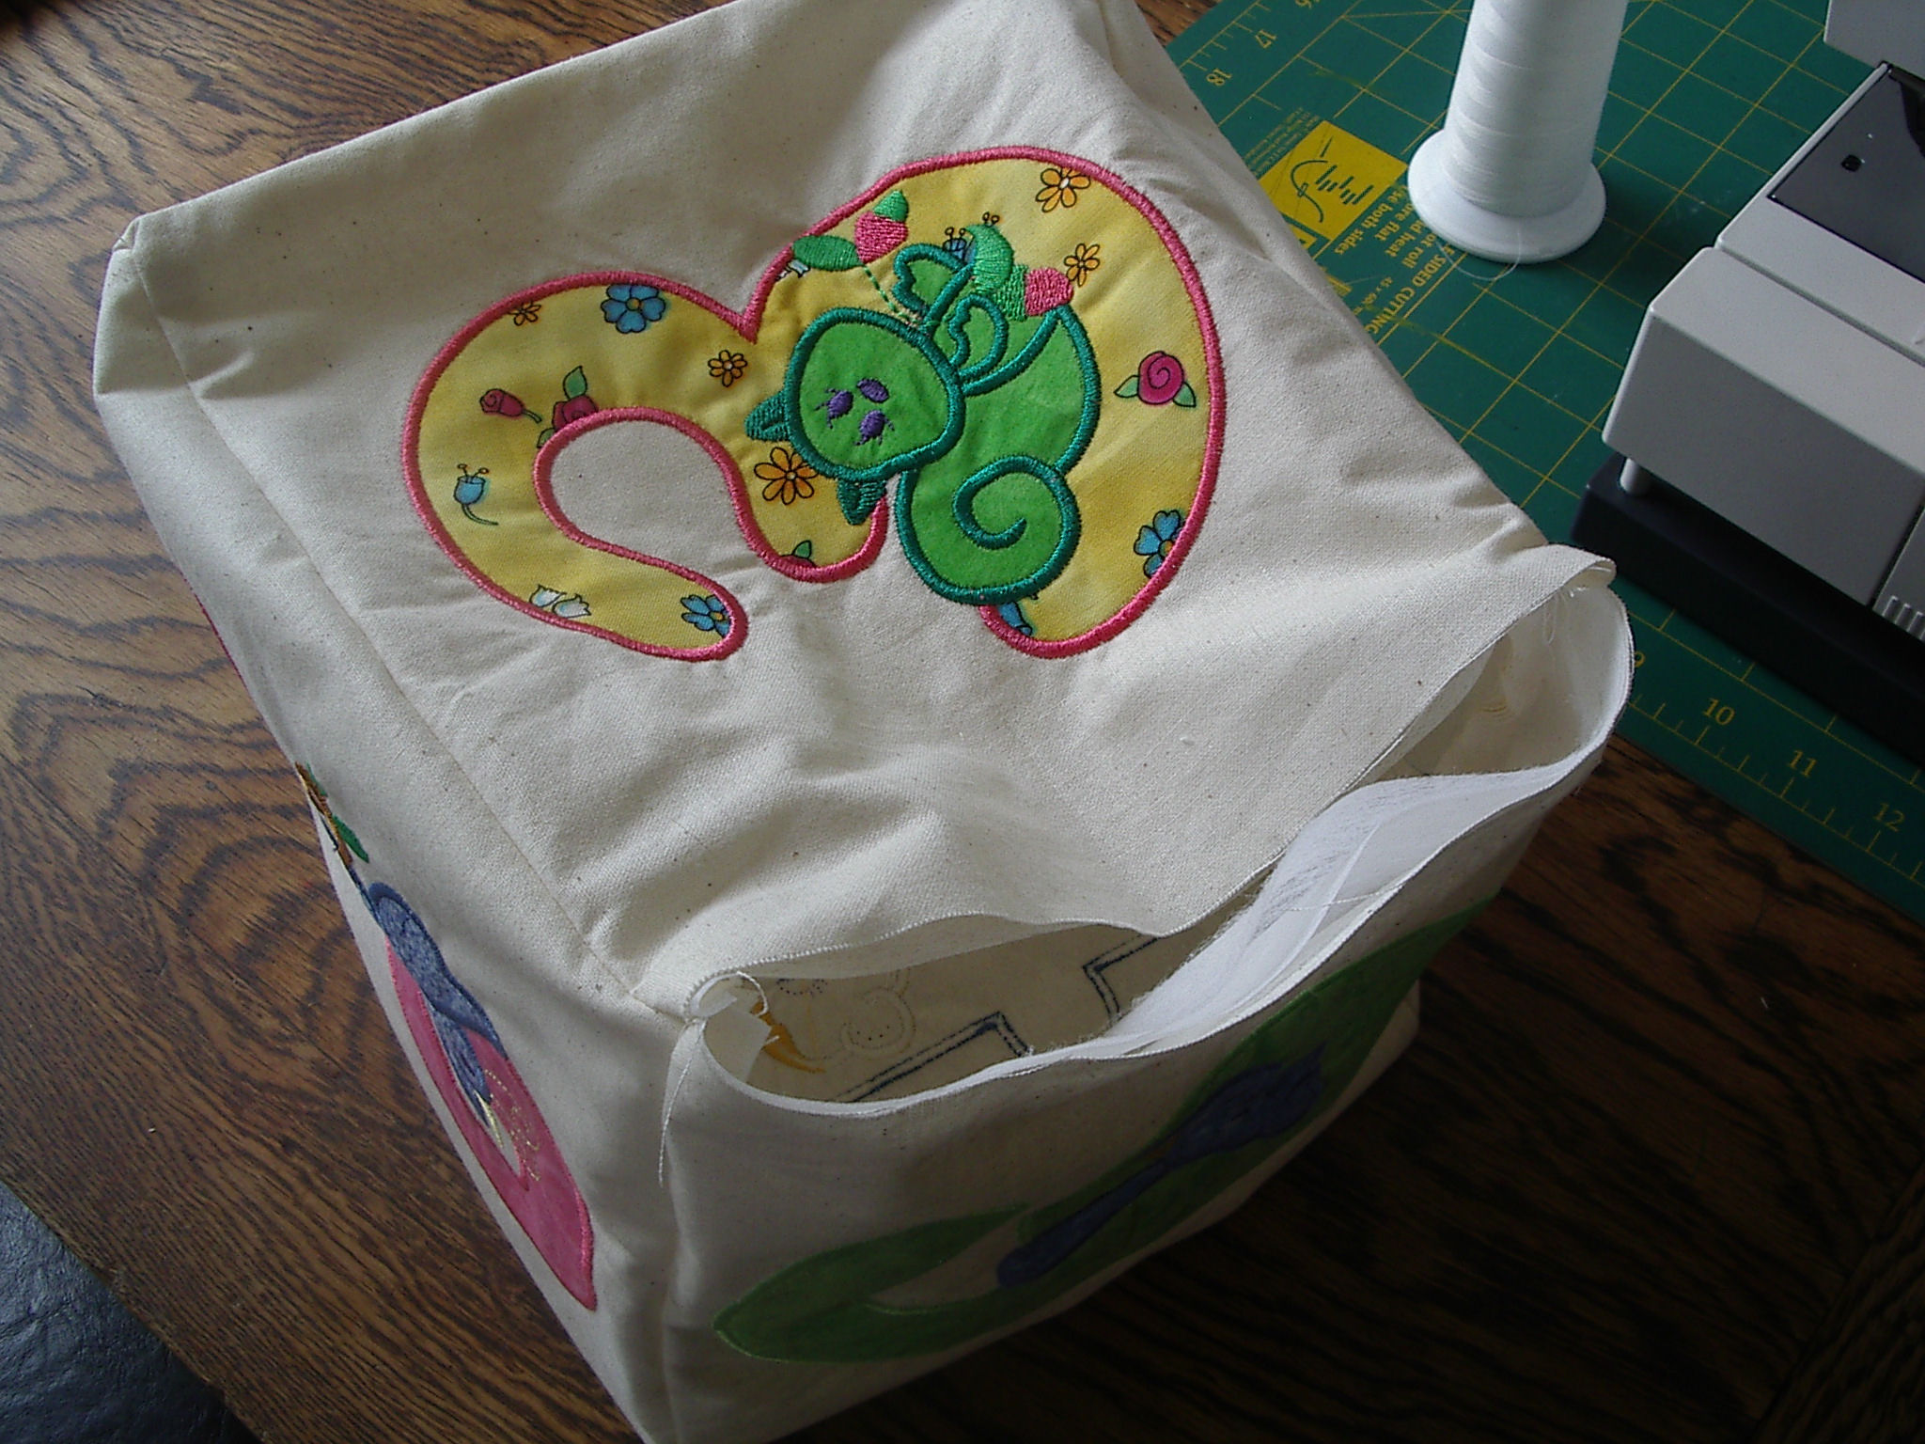

You will be able to sew all seams together – bar one, which you will need to hand sew closed after you have filled the dice.

AND THATS IT – Happy Sewing!

